Project Design Phase-II

Data Flow Diagram & User Stories
Date | 18 June 2026
Team ID
Project Name | ShopEZ
Maximum Marks | 4 Marks

Data Flow Diagrams:
A Data Flow Diagram (DFD) is a traditional visual representation of the information flows within a system. A neat and clear DFD can depict the right amount of the system requirement graphically. It shows how data enters and leaves the system, what changes the information, and where data is stored.

Example: ShopEZ order placement & tracking flow
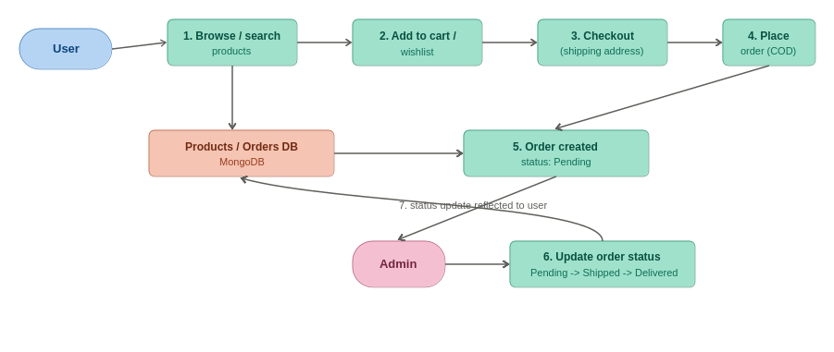
Figure 1: ShopEZ data flow — browsing to order tracking

Flow
1. User browses and searches products on the Products page (live search, category/gender filters, sorting).
2. User selects a product, adds it to Cart or Wishlist.
3. User proceeds to Checkout and enters shipping address for a Cash-on-Delivery order.
4. Frontend sends a POST request to /api/orders with the cart items, address, and JWT token.
5. Backend creates an Order document in MongoDB with status 'Pending', linked to the user and products.
6. Admin logs into the Admin Dashboard, sees the new order, and updates its status (Pending -> Shipped -> Delivered).
7. The updated status is reflected on the user's Orders page when they check order tracking.

User Stories
Following are the user stories for ShopEZ:

User Type | Functional Requirement (Epic) | User Story Number | User Story / Task | Acceptance criteria | Priority | Release
Customer (Web user) | Registration | USN-1 | As a user, I can register for the application by entering my email, password, and confirming my password. | I can access my account and Home page after registering | High | Sprint-1
 |  | USN-2 | As a user, I receive a JWT token once registration is successful and am logged in automatically. | I am logged in and redirected without re-entering credentials | High | Sprint-1
 | Login | USN-3 | As a user, I can log into the application by entering my email & password. | I receive a valid JWT and am redirected to the Home page | High | Sprint-1
 |  | USN-4 | As an admin, I am redirected directly to the Admin Dashboard upon login. | Admin role users land on /admin/dashboard, not Home | Medium | Sprint-1
Customer (Web user) | Home & Browsing | USN-5 | As a user, I can view the Home page with hero banner, category tiles, flash sales, and trending products. | Home page loads with all sections visible and clickable | High | Sprint-1
Customer (Web user) | Products & Search | USN-6 | As a user, I can search products live and filter by category and gender on the Products page. | Product list updates instantly as I type or change filters | High | Sprint-2
 |  | USN-7 | As a user, I can sort products by Popular, New Arrivals, Price (Low to High) and Price (High to Low). | Product order changes correctly based on selected sort option | Medium | Sprint-2
Customer (Web user) | Product Details | USN-8 | As a user, I can view a product's image gallery, specifications, features, brand, stock status, and price. | All product details render correctly on the details page | High | Sprint-2
 |  | USN-9 | As a user, I can increase/decrease quantity, add to cart, buy now, or toggle wishlist on a product. | Quantity updates, item added to cart/wishlist, Buy Now proceeds to checkout | High | Sprint-2
Customer (Web user) | Cart & Checkout | USN-10 | As a user, I can view my cart with live order summary, quantity controls, and total (including delivery fee). | Cart total updates correctly when quantity changes | High | Sprint-3
 |  | USN-11 | As a user, I can enter my shipping address and place a Cash-on-Delivery order at Checkout. | Order is created with correct address, items, and total amount | High | Sprint-3
 |  | USN-12 | As a user, I see a Success/Confirmation screen after placing my order. | Confirmation screen displays order ID and summary | Medium | Sprint-3
Customer (Web user) | Wishlist | USN-13 | As a user, I can view and manage products saved to my Wishlist. | Wishlist page lists saved products and allows removal | Medium | Sprint-3
Customer (Web user) | Order Tracking | USN-14 | As a user, I can view my past orders and track their status. | Orders page lists all my orders with current status | Medium | Sprint-4
Administrator | Admin Dashboard | USN-15 | As an admin, I can view dashboard analytics: total revenue, total orders, users, products, and order status breakdown. | Dashboard stats and charts match actual database values | High | Sprint-4
Administrator | Admin: Users | USN-16 | As an admin, I can view all registered users along with their roles. | Users list shows name, email, and role (USER/ADMIN) | Low | Sprint-4
Administrator | Admin: Products | USN-17 | As an admin, I can add a new product with specifications, features, and multiple uploaded images. | New product appears on Products page with uploaded images | High | Sprint-4
 |  | USN-18 | As an admin, I can edit or delete existing products. | Changes are reflected immediately on the storefront | Medium | Sprint-4
Administrator | Admin: Orders | USN-19 | As an admin, I can search, track, and update order statuses (e.g. Pending -> Out for Delivery -> Delivered). | Updated status is visible to the customer on their Orders page | High | Sprint-4

